For Immediate Release
Contact: Mona Baroudi
415.615.2735
mona@monabaroudipr.com

Joe Goode Performance Group presents the world premiere of Still Standing

An immersive performance through San Francisco’s historic Haas-Lilienthal House
Featuring an original score by Ben Juodvalkis and music by Tassiana Willis, Lila Blue & Shawna Virago

July 12 - August 5, 2018

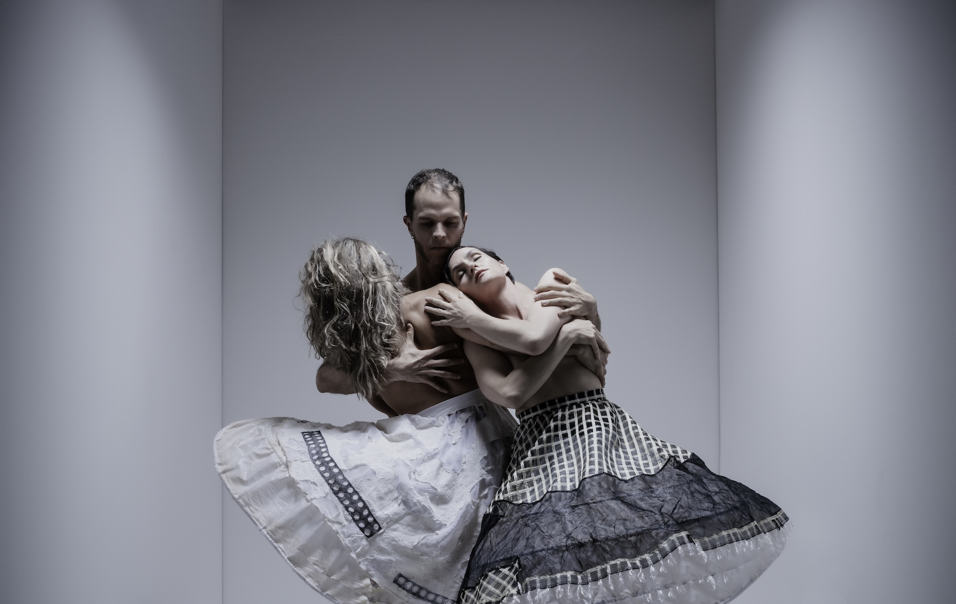
Marit Brook-Kothlow, James Graham, Damara Ganley. Photo by RJ Muna

SAN FRANCISCO, CA, May 4, 2018—The Joe Goode Performance Group presents the world premiere of Still Standing, an immersive performance experience through San Francisco’s historic Haas-Lilienthal house, July 12 – August 5, 2018.

Still Standing is Joe Goode’s latest dance theater work incorporating his signature combustion of movement, word, song, and audience interaction. Using real, written, and imagined stories from the dancers and musicians, Joe Goode explores how we find resilience, persist, and reinvent. The work transports audiences through San Francisco’s historic Haas-Lilienthal House, a mansion built in 1886 that recently completed a $4.3 million restoration. Designed by Peter R. Schmidt for William and Bertha Haas, it survived the 1906 earthquake and fire, and remained in the Haas family until 1973, after which it was entrusted to the San Francisco Heritage to serve as the organization’s headquarters.

“Just as this grand old house is ‘still standing,’ the spirit of San Francisco as a place of alternative thinking, innovation, even reinvention, is still standing,” says Joe Goode. Still Standing asks ‘What do we want to become? Can we be bold enough to reinvent ourselves?’

Still Standing features original music by musician/composer Ben Juodvalkis, in addition to a number of other musical collaborators, including Tassiana Willis, Lila Blue and Shawna Virago. In an effort to highlight the central role music plays in Joe Goode’s work, every Thursday evening will also include a post-show musical performance. Performances will take place July 12 (Tassiana Willis); July 19 (artist TBD), July 26 (Shawna Virago) and August 2 (Ben Juodvalkis).

JGPG company dancers performing are Marit Brook-Kothlow, Damara Ganley, Molly Katzman, James Graham and Patricia West. They are joined by guest dancers Brendan Barthel, Janine Trinidad, Cookie Harrist, Wailana Simcock, Gabriel Christan, El Beh, Caroline Alexander, Pamela Shoebottom, and Jan-Matthew Sevilla.
About Joe Goode
Joe Goode is a choreographer, writer, and director widely known as an innovator in the field of dance for his willingness to collide movement with spoken word, song, and visual imagery. He was awarded a John Simon Guggenheim Fellowship in 2007, and the United States Artists Glover Fellowship in 2008. In 2006 Goode directed the opera Transformations for the San Francisco Opera Center. His play Body Familiar, commissioned by the Magic Theatre in 2003, was met with critical acclaim.

The Joe Goode Performance Group, formed in 1986, tours regularly throughout the U.S., and has toured internationally to Canada, Europe, South America, Africa, and the Middle East. Goode is known as a master teacher; his summer workshops in “felt performance” attract participants from around the world, and the company’s teaching residencies on tour are hugely popular. He is a member of the faculty of the University of California, Berkeley in the department of Theater, Dance and Performance Studies.

Goode’s performance-installation works have been commissioned by the Fowler Museum of Natural History in Los Angeles, Krannert Art Museum, the Capp Street Project, the M.H. de Young Museum, and Yerba Buena Center for the Arts. His dance theater work has been commissioned by Pennsylvania Ballet, Zenon Dance Company, AXIS Dance Company and Dance Alloy Theater among others. Goode and his work have been recognized by numerous awards for excellence including the American Council on the Arts, the New York Dance and Performance Award (Bessie), and Isadora Duncan Dance Awards (Izzies).

CALENDAR EDITORS, PLEASE NOTE:

WHEN:
Thursday, July 12, 8pm: Post-Show Concert: Tassiana Willis
Friday, July 13, 8pm
Saturday, July 14, 5:30pm & 8pm
Sunday July 15, 3pm & 5:30pm
Thursday, July 19, 8pm: Post-Show Concert: Artist TBA
Friday, July 20, 8pm
Saturday, July 21, 5:30pm & 8pm
Sunday July 22, 3pm & 5:30pm
Thursday, July 26, 8pm: Post-Show Concert: Shawna Virago
Friday, July 27, 8pm
Saturday, July 28, 5:30pm & 8pm
Sunday July 29, 3pm & 5:30pm
Thursday, August 2, 8pm: Post-Show Concert: Ben Juodvalkis
Friday, August 3, 8pm
Saturday, August 4, 5:30pm & 8pm
Sunday, August 5, 3pm & 5:30pm

WHERE:
The Haas-Lilienthal House,
2007 Franklin Street at Jackson, SF

TICKETS:
$45-65, with Pay What You Can tickets available for select shows
Tickets available at www.joegoode.org

